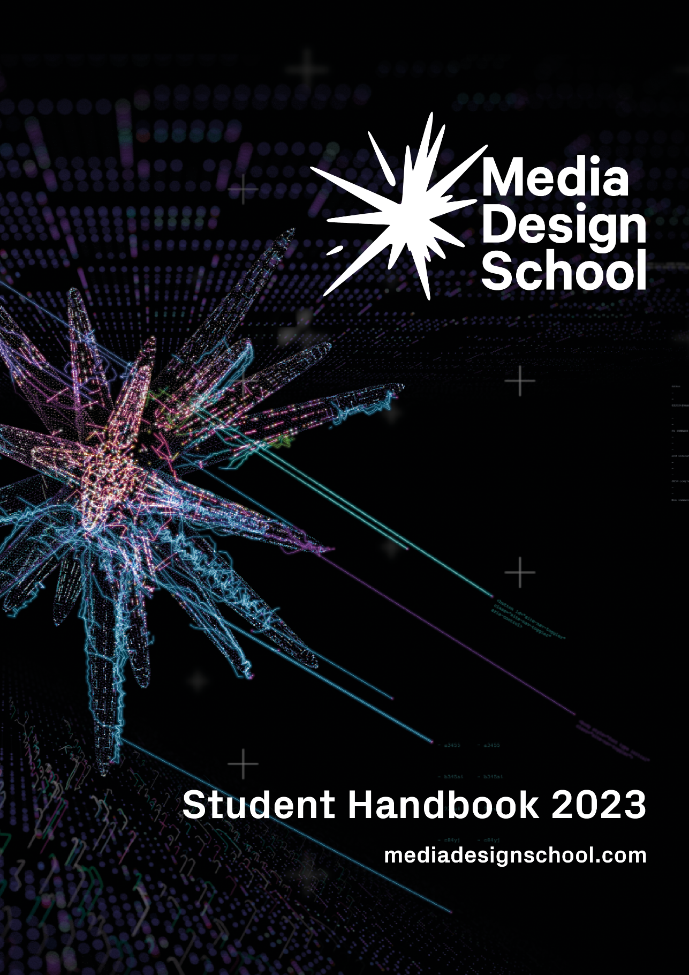

Disclaimer: Media Design School reserves the right to make changes to the information contained within the Student Handbook, including policies and procedures, as required. Please refer to www.mediadesignschool.com/student-information for updated information.
Updated 23 May 2023.
General 1
Accreditation and Registration 1
Disclosure of Information 1
Fees 1
Student Fee Protection 2
Government Funding – Domestic Students 2
Payment of Fees 2
Outstanding Debts and Fees 3
Withdrawal and Refunds 3
Academic Information & Policies 5
Student Information and Records 5
Release of Student Information 6
Academic Records 6
Award of Qualification 6
Attendance 7
Notification of Absence 7
Non-attendance of classes 8
Academic Integrity 9
Assessment 9
Moderation 10
Assessment in Te Reo Māori 11
Resubmission 11
Assessment Appeals 11
Extension to an Assessment Deadline 12
Academic Progression 12
Transfers 13
Compassionate Transfers 13
Transfer to new Qualification 14
Restart Transfer 14
Guide to Selecting Transfer Type 16
Student Learning 17
Class Schedules 17
Recording Lectures and Audio-Visual Notes 17
Independent & Self-Directed Learning 17
Online – Teaching and Learning 17
Internet Use 18
Student Evaluations & Surveys 18
Student Equipment & Resources 18
Library Service 19
Copyright 19
Intellectual Property 20
Client Briefs - Production and Delivery 20
Terms of Reference for Client Briefs – Non-commercial (unpaid) 20
Student Life 21
Student Executive 21
Student Communications 21
School Hours and Access 21
Holiday Breaks 22
Visitors 22
Letters of Reference 22
Student Events 22
Clubs 23
Student Guidance and Support 23
Tertiary and International Learners Code of Practice 23
Counselling Services 24
Life Coaching 24
Wellness Workshops for Students 25
Disability and Learning Needs Support 25
Health and Safety 26
Accident Reporting 26
Hazard Identification 26
Emergency Contact 26
Fire and Evacuation Procedures 27
Technical Faults and Maintenance Reporting 27
Food and Drink 28
Security 28
Student ID Cards 28
Student Conduct 29
Disciplinary Procedures 30
Student Complaints 30
Types of Complaint 32
Academic Complaints 32
Non-academic Complaints 32
Complaint Resolution 33
Informal Discussion 33
Formal Complaint 33
Internal Appeal 34
External Review 34
Record Keeping 35
Class Complaints 35
False Allegations 35
Graduation 35
Graduation Ceremonies 36
Alumni 36
What happens to my work when I have completed my qualification? 36
International Students 37
Emergency Contact 37
International Student Support 37
Our Responsibilities to International Students 37
What if something goes wrong? 38
Student Contract Dispute Resolution Scheme 39
Medical and Travel Insurance 39
Working in New Zealand 40
Driving in New Zealand 40
Emergency and Health Services 40
Emergencies 40
Non-emergencies 40
Doctors & GPs 40
Pharmacies 40
Auckland Public Hospitals 41
Auckland Mental Health Services (Adult, requires GP referral) 41
External Support Services 41
Government 41
Info for International Students 42
Auckland Council 42
Wellbeing Support 43
Community Support 44

General

Accreditation and Registration
Media Design School is registered as a Private Training Establishment (PTE) by the New Zealand Qualifications Authority (NZQA) under the provisions of the Education and Training Act 2020 and its subsequent amendments. NZQA, under the provisions, of the Act approves and accredits Media Design School’s qualifications.
NZQA uses External Evaluation and Review (EER) to review the current quality of performance within Tertiary Education Organisations (TEOs). After an EER, NZQA places TEOs into one of four categories based on their EER statements of confidence. The categories are 1 (highest) to 4 (lowest).
Media Design School is placed as a Category 1 TEO and is reviewed every four years.

Disclosure of Information
Once receiving an offer of place, applicants will receive information regarding the following:
- Student Fee Protection (Public Trust)
- Government funding (Domestic Students only)
- Media Design School’s Withdrawal and Refund Policy

Fees
Tuition Fees are published on the school’s website. The New Zealand Government funds domestic students through Student Achievement Component (SAC) funding.
Government funding does not apply to international students and international student fees are published separately.
Fees listed are for each academic year of study. Fees are in New Zealand dollars.

Student Fee Protection
All PTEs registered with NZQA are required to offer protection for student fees paid and other course-related costs.
The school has selected Public Trust to act as an independent trustee. As soon as fees are deposited with Public Trust, they are protected. As students progress through their course of study, the fees paid are gradually released to the school.
In the unlikely event of any regulatory closure of the school, the school, through Public Trust, will ensure that any refund owed to a student will be made in accordance with the Education and Training Act 2020 and the current NZQA Student Fee Protection Rules 2022.
For more information on Public Trust’s student fee protection, please visit the Public Trust website.

Government Funding – Domestic Students
TEC funds a set number of domestic students for all qualifications offered at the school through SAC funding.
For the purposes of SAC funding, a domestic student is one of the following:
- A New Zealand citizen, which includes Cook Island, Niue, and Tokelau citizens
- A New Zealand permanent resident, currently residing in New Zealand
- An Australian citizen, currently residing in New Zealand
- An Australian permanent resident with a returning resident’s visa, currently residing in New Zealand
- Certain exchange students and dependents of diplomats.

Payment of Fees
Upon registering to a course of study at the school, students accept full responsibility for payment of their fees by the due date, as per their invoice.
The following outlines the time frame and procedure for non-payment of invoices after the start date of the qualification:
Day 8: All fees must be paid in full. If any fees are still outstanding, the student must provide evidence that they have applied for a student loan, and is now obligated to pay fees in full, as per the Withdrawal and Refund Policy.
Day 15: If there is still no evidence of a student loan application and a verification of study has not yet been received by the school or fees receipted, the student will be restricted from all classes until this process is completed.
Day 22: If the student’s fees are still outstanding (with no exceptional circumstances), the student will be deregistered from their course of study and the appropriate authorities notified. No refund will be granted.
Note: It is the student’s responsibility to make up the time and learning for any lessons missed due to being suspended for unpaid fees.

Outstanding Debts and Fees
Any outstanding debts or fees payable to the school are referred to the school’s debt collection agency for recovery. This includes any costs incurred through damaged or lost equipment or resources loans. Administration and recovery costs are added to the original debt.

Withdrawal and Refunds
The school has specific rules regarding when a refund will be granted and the amount that will be paid. Students are required to follow the Media Design School Withdrawal and Refund Policy.
If a student withdraws prior to the start of the course of study, they will be entitled to a full refund.
Domestic students who withdraw from a course of study up to the end of the eighth calendar day, after the commencement of an intake of a qualification, will be refunded the payment(s) made, minus the Administration Fee (NZD$500 or 10% of the amount paid, whichever is the lesser).
International students who withdraw from a course of study up to the end of the tenth working day, after the commencement of an intake of a qualification, will be refunded between 75% and 90% of their tuition fees, noting the school has the right to retain fees that are reasonable to cover the expenses already incurred when the student withdraws within this period (Education (Refund Requirements for International Students) Notice 2012).
International students whose visa gets declined, will be refunded the full amount paid. The original INZ letter declining the visa application must be provided. If an international student obtains permanent residency during their course of study, the fees will not be adjusted and no refunds will be granted.
Students will not be refunded for any student workbooks, equipment, or textbooks they have been supplied with during this period.
Students must pay all outstanding payments and have returned all equipment and resources belonging to the school before any withdrawal approval is given. Please refer to the Media Design School Withdrawal and Refund Policy for further information.
Student Withdrawal Fee Refund Flow Chart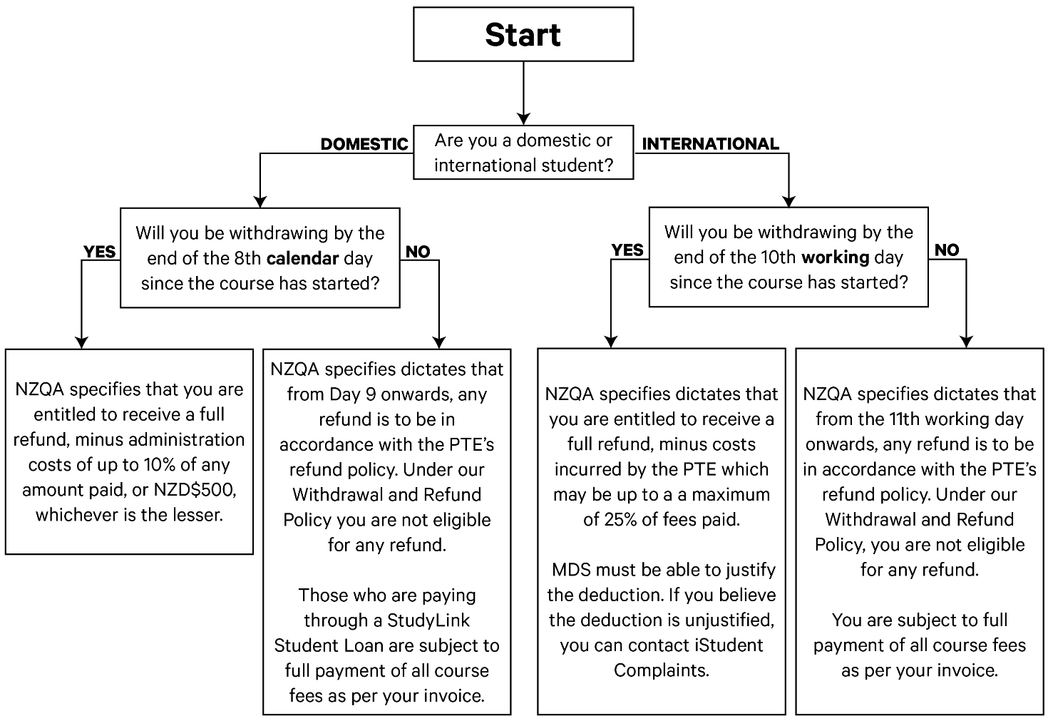
Please note, this diagram only applies to courses longer than 3 months.

Academic Information & Policies

Student Information and Records
All information and data required for the Ministry of Education (MoE), Tertiary Education Commission (TEC) and NZQA compliance, and for the school’s own records, is stored and processed in adherence with the Privacy Act 2020.
Media Design School is obligated to provide post-study outcomes data (graduates' destinations and earnings data after completing study) to TEC. Once you have completed your studies, you will be asked to provide your contact address.
Note: Media Design School is required to keep up-to-date records for all students. You must ensure your contact details, such as your name, phone number and email addresses, are kept up to date. If you need to make any amendments to your contact details, please contact Reception on Level 1 or via email: reception@mediadesignschool.com.

Release of Student Information
Media Design School is required to submit regular reports to the MoE. Media Design School is also required to release, or make available for audit, information that is specific to student enrolments. MoE, TEC and NZQA may access your attendance records, academic records and information regarding your student allowance and loan applications, as requested by an authorised officer of the said agencies.
Each student has a National Student Index (NSI) number that is used to track your enrolment, completion, or withdrawal at all New Zealand education institutions you are or have been enrolled at.

Academic Records
A final academic transcript is provided at the conclusion of your course of study. The transcript is posted or emailed to your address or email of record at the time of qualification completion.
If you require a copy of your transcript, please contact Student Administration via email: studentadmin@mediadesignschool.com.
Reprints of official Media Design School documents (transcripts and award certificates) can be ordered via Student Administration for a fee.

Award of Qualification
To be awarded a qualification by Media Design School, you must meet the following requirements:
- they meet all course requirements
- they have no outstanding fees
- there are no current suspension, exclusion or expulsion penalty on the student’s record, and
- they have not already graduated from that programme.
For more information see the Graduation and Certification Policy.

Attendance
Attendance for all scheduled classes (labs, tutorials, presentations, site visits and other classes) is mandatory.
You must also be on time. The school mimics the realities of the workplace, and you are expected to treat your study as if you were in the workplace.
International students: 100% attendance is a condition of your study visa.

Excused Absences
There are two exceptions to the attendance requirements: sickness and bereavement. It is your responsibility to provide evidence to the school for an excused absence.

Sickness
You are required to provide a medical certificate for absences of three or more consecutive scheduled class days due to sickness. If you require an extended excused absence due to sickness, your attendance requirements will be assessed individually.

Notification of Absence
If you are absent, you must:
- Notify your lecturer or Programme Leader, and email away@mediadesignschool.com, or
- Notify the school by contacting reception on 09 303 0402.
Notifications of absence must be made prior to commencement of scheduled class(es).
If you are absent for any reason, you will be responsible for catching up on any missed work or collecting any information provided by your lecturer(s) (e.g., handouts, formative assessments, summative assessments).

Non-attendance of classes
Media Design School is legally required to immediately inform StudyLink (domestic students) or Immigration New Zealand (international students) when:
- You cease to attend scheduled classes.
- Your attendance is unsatisfactory.
- You are considered no longer eligible to achieve your qualification.
Non-attendance will be addressed if you have an unexcused absence for three consecutive scheduled class days. If this occurs, the notification process is as follows:
- You will be referred to the Student Counsellor or Māori & Pasifika Success Coach, by Lecturer or Programme Director
- Lecturer or Programme Director will inform you of the reason for the referral
- You will be required to complete Student Services forms issued by Student Administration
- The Student Counsellor or Māori & Pasifika Success Coach will notify the lecturer of any response or outcome within 3 days of contact with the student.
If non-attendance continues:
- You will be issued a first warning letter for non-attendance by your Programme Director
- For minor offence with no improvement, you will be issued a second warning letter by your Programme Director
- For major offence with no improvement, you will be issued with an Academic Probation Contract by your Programme Director
Following the above measures, if non-attendance continues, your enrolment may be cancelled.
Please refer to the Media Design School Academic Progression Policy for further information.

Academic Integrity
Academic misconduct takes place when students act dishonestly in an assessment task or examination in order to gain an unfair advantage for themselves or other students. Examples of academic misconduct include plagiarism, cheating in examinations, collusion, and contract cheating. See section 6 of the Academic Integrity Policy for more information on academic misconduct.
Acts of academic misconduct are considered to be misconduct as defined under the Student Conduct Policy. All allegations of academic misconduct will be investigated by the Programme Director or Coordinator (or delegate), and if substantiated will result in the provision of academic counselling and may result in penalties appropriate to the case.
Depending on severity, consequences may include a downgrade in the relevant mark, a Fail grade, suspension, exclusion, or expulsion. See section 8 of the Academic Integrity Policy for more information on the penalties for academic misconduct.
Assessment
Assessment at the Media Design School (MDS) is linked to specific learning outcomes and based on clearly articulated criteria that help students understand the characteristics of high-quality work. It supports student-centred approaches to learning. In keeping with the strongly applied focus of MDS to teaching and learning, MDS endorses relevant, diverse forms of assessment primarily drawing on real-life practice. Assessment tools are either formative or summative.
Formative assessments are designed to help students and staff to identify strengths, weaknesses and ways to improve and enhance student learning. It is intended to support student learning rather than determine a final grade or mark.
Summative assessment evaluates the quality of students’ learning, and involves assigning a grade or numerical result based on how effectively students have addressed learning outcomes.

The following chart outlines the grading scale used for assessment:
Grade | Range | Value
A+ | 100 – 90% | 100%
A | 89% – 85% | 88%
A- | 84% – 80% | 83%
B+ | 79% – 75% | 78%
B | 74% – 70% | 73%
B- | 69% – 65% | 68%
C+ | 64% – 60% | 63%
C | 59% – 55% | 58%
C- | 54% – 50% | 53%
D | 49% – 0% | 0%
A grade for each component of your course of study will appear on your academic transcript.

Moderation
Each summative assessment is moderated (before and after) internally by faculty and may also include external moderation if significant changes are made to assessments. Final semester or year assessments (i.e., capstone projects) are externally post-moderated by faculty from other New Zealand education institutions.

Assessment in Te Reo Māori
To complete your summative assessment or submit formal work in Te Reo Māori, you must notify your Programme Leader before you submit your assessment

Resubmission
If you fail a summative assessment there may be one opportunity to resubmit. Information regarding resubmissions must be provided to you before the commencement of the component. You will need to discuss resubmission with your lecturer or Programme Leader.
A resubmission may not be available for final year production, project, or portfolio summative assessments in specific courses of study. Resubmissions must be completed within the set timeframe allocated by your lecturer. If you fail the resubmission, there will be no further opportunities to resubmit. Your Programme Leader may discuss a further opportunity through an Individual Learning Plan.
The highest grade you can receive on a resubmission is C- (50%).
All late resubmissions will receive a D (fail) grade.
Slight variations to the above are permitted if clearly communicated to you.

Assessment Appeals
You have three days after being provided with a summative assessment result to appeal the outcome:
- Before lodging an appeal, you should first seek clarification of the result from your Programme Leader. The Programme Leader may decide to have your assessment marked again by an independent assessor to demonstrate consistency of marking.
- You have two weeks after being provided a final assessment result to appeal the outcome. It is important to note, final qualification results are moderated prior to release.
- If your appeal remains unresolved, you may submit a written appeal to the Associate Dean. The submission must provide supporting evidence for the appeal to be considered. You have three days to make an assessment appeal.
- The Associate Dean will communicate the outcome of the appeal in writing to you. Note: There is no further internal appeal process.
- If you are dissatisfied with the outcome, you are advised to seek an independent external adviser. Please contact the Registrar via email at studentadmin@mediadesignschool.com, who can provide you with information on the next steps.

Extension to an Assessment Deadline
Meeting assessment deadlines is an important part of preparing you for employment. Assessments are therefore all time-based. A request to extend an assessment deadline may only be approved in exceptional circumstances, which includes family bereavement, emergency, or extended periods of sickness. Extensions will be granted at the discretion of your Programme Leader.
You will be responsible for providing supporting evidence that demonstrates you meet an exceptional circumstance. Requests for an extension should be in advance of the deadline and will not be granted due to a lack of planning, equipment availability or technical difficulties.
Please refer to the Media Design School Assessment Policy for further information.

Academic Progression
While students have the primary responsibility for their academic performance, MDS emphasises the pivotal role of academic and support staff in enabling student success. In the first instance, you should discuss the situation with academic staff for referral to your Programme Director or Coordinator.
If the situation persists or in exceptional circumstances, where a situation outside of your control is affecting your studies, you may submit a request in writing to the Associate Dean who will assess your request on a case-by-case basis.
If a student’s progress remains unsatisfactory, MDS may impose conditions on the student’s continued enrolment or the student may be excluded from continuing their studies.

Transfers
Media Design School supports the right of students to transfer from a course of study under a number of circumstances. To complete a transfer, students must contact Student Administration and complete a transfer form. Please contact Student Administration via email at studentadmin@mediadesignschool.com.
Please refer to the Media Design School Academic Progression Policy for further information.

Compassionate Transfers
Compassionate transfers are granted under exceptional circumstances. Exceptional circumstances often occur when a situation outside of your control is preventing you from completing your course of study successfully within the scheduled end date.
Exceptional circumstances include:
- Major trauma or injury
- High-risk situation or significant illness
- Death of an immediate family member
- Natural disaster or event impacting on a community or communities
If any of these circumstances occur, you should contact your lecturer and Programme Leader who will advise you on the next steps. This may involve a confidential discussion with the Student Counsellor or the Māori and Pasifika Success Coach, who can assist with completing relevant documentation. The final decision will be made by the Programme Leader and Associate Dean.
If the transfer is granted, your course of study will be placed on hold, and you will re-enter your course of study in the following intake or year (if the course of study is offered). If a transfer is approved, you are liable for all fees as invoiced and no refunds will be granted.
Domestic students: StudyLink will be advised by Media Design School of any changes to your study. With regards to Student Allowance, you must speak with StudyLink to also advise any changes to your study.
International students: Immigration New Zealand will be notified of your situation. You will be responsible for obtaining a new visa, as well as any costs involved with the new course. INZ defines a full-time international student studying at a private training establishment (PTE) as being enrolled in a course of study that requires attendance of a minimum of 20 hours per week.

Transfer to new Qualification
If you decide to change from the qualification in which you are enrolled into a new course of study, you must follow the withdrawal process for your current enrolment and reapply for entry to the new qualification in the following available intake as a new enrolment.
If the transfer is approved, you are liable for all fees as invoiced and no refunds will be granted. If you are accepted onto the new qualification you will be invoiced for the full tuition for the year.
Domestic students: StudyLink will be advised for Student Allowance purposes. Please note that if you are applying for a student loan through StudyLink for the next course of study, you will need to have successfully completed at least half of the EFTS of the current course of study to be eligible for StudyLink student allowance/loan.
International students: Immigration New Zealand will be notified of your situation. You have full responsibility for organising a new visa as well as any costs involved with the new course of study.

Restart Transfer
If you enrol in a qualification but fail a number of components during your course of study and wish to stop and ‘restart’ as part of a following intake, the number of credits and EFTS completed must first be considered.
If you fail no more than 30 credits, then you must stay with the programme and re-sit the components as agreed in an Individual Learning Plan (ILP). The re-sit process must be followed in this case, and you will be charged for the components you have failed.
If you fail more than 30 credits, then you must withdraw and reapply for entry in the following year.
In this scenario, you are considered as a new enrolment, and you are liable for all fees as invoiced, and no refunds will be granted. If you are accepted onto the Restart Transfer, you will be invoiced for the full tuition for the year.
You may request Recognition of Prior Learning (RPL) for components already passed. If this is granted, then you do not need to retake these components and tuition fees will be reduced by the component fees.
Domestic students: StudyLink will be advised for Student Allowance purposes. StudyLink policy dictates that students undertaking a course that is 32 weeks – 52 weeks in duration must have at least 0.8 EFTS to be eligible for a student loan. If students are part-time students (full year or part year) they are eligible for a loan for their fees but not for their course-related costs and living costs. The student’s performance will be accessed by StudyLink.
International students: Immigration New Zealand will be notified of your situation. You have full responsibility for organising a new visa as well as any costs involved with the new course of study. Immigration New Zealand defines a full-time student studying at a Private Training Establishment (PTE) as being enrolled in the following:
- A course of study that requires attendance for a minimum of 20 hours per week
- At least three papers, or equivalent, per semester if the offered course is at level 7 or above on the New Zealand Qualifications Framework.

Guide to Selecting Transfer Type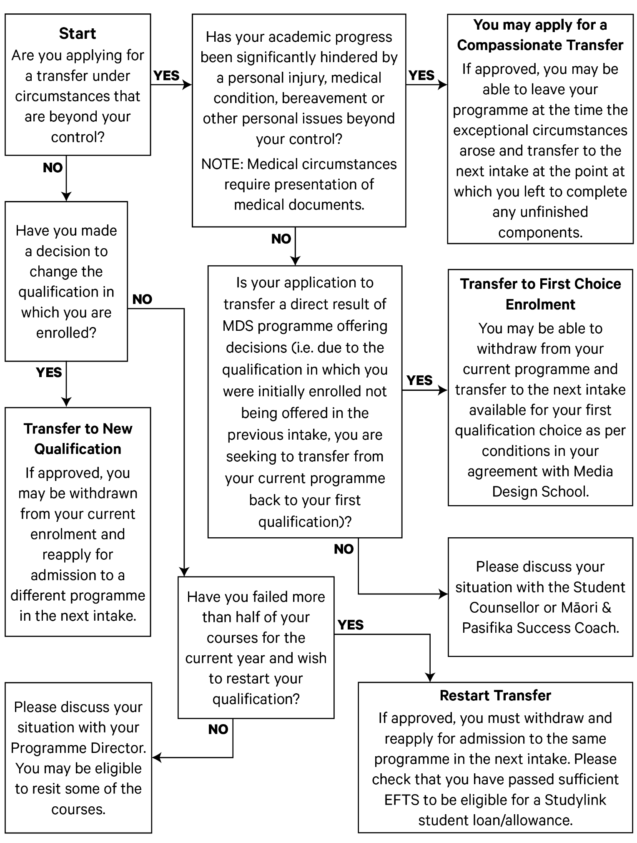

Student Learning

Class Schedules
Class schedules are set by the school and are distributed at the beginning of each semester. All scheduled classes (including tutorials and off-site field trips) are mandatory.

Recording Lectures and Audio-Visual Notes
Recording lectures, tutorials or taking audio-visual notes during any school event, where permission has not been explicitly given, is strictly prohibited.

Independent & Self-Directed Learning
In addition to class time (directed learning), you are expected to engage in self-directed learning. This learning plays a critical role in the education offered by the school and is a major component in gaining a qualification. All full-time students are expected to engage in at least 20 hours per week of self-directed learning.

Online – Teaching and Learning
Media Design School has been approved by NZQA to provide a range of delivery modes to support blended teaching and learning. These include online (onshore and offshore), and face-to-face.
The inclusion of an online delivery mode utilises established tools within each programme and includes both synchronous and asynchronous teaching and learning.
Our virtual learning environment and learning management system (Blackboard) has been integrated to support teaching and learning. Blackboard provides students with access to course materials, communication tools, online assessments, grades, attendance, and the ability to submit assignments electronically. Webinars are used for interactive tutorials, lectures, discussions, group forums and workshops.

Internet Use
The internet must, at all times, only be used for educational and research purposes. Inappropriate use of the internet includes but is not limited to:
- Activities prohibited by legislation
- Downloading entertainment materials
Except where required for the purposes of study, as determined by your lecturer or Programme Leader, this also includes:
- Gaming
- Online chatrooms
- Peer-to-peer file sharing
- Instant messaging

Student Evaluations & Surveys
You will be invited to complete evaluations and surveys throughout your course of study. The results will be shared with the appropriate departments and any related actions will be communicated to you through your lecturer or Programme Leader, including posters around the school.
Course evaluation surveys will be undertaken within each programme and the trends of the surveys will be used to make improvements to content and delivery.

Student Equipment & Resources
The school may loan equipment and resources to students including cameras, video cameras, and related equipment. The loan system relies on the proper use and care of the equipment and resources, and the return by the due date.
You must honour the loan requirements. If you fail to return equipment or resources by one week after the due date, you may be charged and invoiced at the full commercial replacement cost, plus an administration fee, and you may not have further access to borrowed equipment and resources.
If you have any outstanding equipment or resources fines at the conclusion of your course of study, you may have your debt referred to a debt collection agency and your academic records and transcript may be withheld.

Library Service
The library is located on Level 1 of the campus. The library can also be accessed virtually 24/7.
The library provides the following services and resources for your studies:
- Articles, books, eBooks, journals, subject guides, visual collections and peer reviewed materials
- Academic skills support
- Academic integrity and referencing guides
- Blackboard support
- Copyright guide
- Databases
- Referencing support
- Study success workshops
- Live chat
If you wish to speak with the Campus Librarian, borrow resources or work on your assignments, you can visit the library on Level 1 or email: library@mediadesignschool.com.

Copyright
MDS supports the legitimate use of third-party copyright material for the purpose of providing MDS educational activities. It is committed to the proper observance of copyright law, and to upholding the rights of copyright creators and users.
Students produce work using educational and academic software licences. It is a condition of these licences that they are not used in the production of any commercial work.
For more information, please review the Copyright Policy.

Intellectual Property
Students own the IP they create in the course of their studies (including students in Doctor and Master of Philosophy courses) unless there is a specific written agreement or exception to the contrary.
To participate in certain projects, including those which are externally funded, students may need to assign any right, title, or interest they may have in the IP. Where the student is a higher degree research student, the research thesis principal supervisor is responsible for identifying circumstances when the assignment of student IP is appropriate. Where a student is undertaking coursework, the Programme Director is responsible for identifying circumstances when the assignment of student IP is appropriate (e.g., work integrated learning placements).
For more detail, please see the Intellectual Property Policy.

Client Briefs - Production and Delivery
During your course of study, you may be requested to produce work using simulated client briefs and/or actual client briefs. No payment will be made to you for the work produced.

Terms of Reference for Client Briefs – Non-commercial (unpaid)
- All work completed using the school’s software licenses must be non-commercial.
- Associated costs of client work (i.e., site transportation) are your responsibility.
- Media Design School is not responsible for any production costs associated with client work.
- If you are working directly with a client, you must make sure the client is aware of any production costs that they will be responsible for (i.e., printing, plates, internet charges).
- You must inform the client of the time you are able to commit to the project.
- The client should be informed that they have no recourse from you, or Media Design School should the work not meet the client’s expectations and/or time frame.

Student Life

Student Executive
The Student Executive Committee is formed by currently enrolled students who serve as representatives, with different areas of responsibility. Led by the Chair, the Executive works closely with the Student Services team and plays a significant role in:
- Leading the Student Voice and to represent the student body.
- Promoting the interests of students.
- Supporting student engagement initiatives.
- Advising on engagement with Māori and Pacific communities.
- Supporting the school to deliver on strategic equity objectives.
- Supporting the development of school policies.
- Advising on the school’s academic structure.

Student Communications
Regular communications are sent to your school email addresses to keep you updated on news, events, and information.
In addition, school information and updates are posted on student notice boards throughout the campus and online via the Student Information Hub, Discord, and Facebook.

School Hours and Access
- Students can access the campus using their student ID card, during the following operating hours: Monday to Thursday: 8:00 am to 9:00 pm
- Friday: 8:00 am to 6:00 pm
- Saturday: 10:00 am to 5:00 pm
- Sunday: Open to Postgraduate and Master students
Access to student servers cease at the above closing times (there are no exceptions). If you are printing, saving, burning, or rendering at the time of closing, you will need to abandon the work.
Reception business hours are 8:00 am to 5:00 pm, Monday to Friday.

Holiday Breaks
The school is closed during all New Zealand observed public holidays and Auckland Anniversary Day.

Visitors
You are required to gain prior permission from your lecturer and Programme Director if you wish to bring a visitor into the school. No visitors are permitted during the weekend or after 5:00 pm on weekdays. You must accompany your visitor at all times. No visitors may enter classes that are in progress or use any school computers, resources, or equipment.

Letters of Reference
Lecturers are not required to provide written references for students. If you wish to use a lecturer as a verbal referee, you must request permission from your Programme Director before you approach your lecturer.

Student Events
The school arranges several events throughout the year, both on and off campus, where you can showcase your work to influential members of the creative community and to the general public. The school also holds events, such as film screenings and a range of other activities, for you to get involved in with other students and faculty.
All upcoming student events and news are posted by the Student Services team on Discord.

Clubs
Student clubs enrich the school experience and provide opportunities for students to make new friends, meet like-minded people and develop new skills.
For more information on clubs or to start your own, pleases contact the Student Executive or the Student Services team.

Student Guidance and Support
Guidance and support at the school is available through different channels to ensure your learning needs are met and barriers to your progress are minimised. The first point of contact for guidance and support is your lecturer. You can also contact your Programme Director, Student Counsellor, Student Services staff or the Campus Director.

Tertiary and International Learners Code of Practice
Tertiary education providers have an important role in ensuring the safety and wellbeing of all students.
The Tertiary and International Learners Code of Practice supports the wellbeing of tertiary and international learners enrolled with New Zealand education providers.
It sets out the expectations that education providers must meet for the wellbeing and safety of their students.
NZQA is the administrator of the Tertiary and International Learners Code of Practice, responsible for monitoring and supporting providers to give effect to the Tertiary and International Learners Code of Practice.
This Tertiary and International Learners Code of Practice applied from 1 January 2022, replacing the previous Codes of Practice.
You can download a copy of the Tertiary and International Learners Code of Practice from the NZQA website. The NZQA website also has a summary of the Code of Practice.

Counselling Services
The counselling service provides individual counselling for personal and relationship issues. It also provides interventions for students with habitual absences and other behavioural concerns that consistently interfere with student learning. Counselling sessions aim to support students to identify solutions and reinforce a sense of ownership and control.
The type of counselling available at the school is brief intervention, not long-term therapy. If a student requires more than the standard five to seven sessions, the Student Counsellor may refer a student to another community counselling service off campus. They may also refer students with long-term or specialised counselling and medical needs to external (both public and private) mental health practitioners, including psychologists, psychiatrists, and general practitioners.
Academic staff refer students with habitual absences, tardiness, lack of concentration within the classroom, homesickness, low self-esteem, relationship conflict, work or family-related problems, and other behaviours that may impact the ability to study effectively.
Academic challenges, including understanding course content, missing deadlines, and maintaining a high degree of motivation for the course, should be referred to the Programme Director for academic support.

Life Coaching
The life coaching service is available to help new students adjust to life at the school and in Auckland. This service is facilitated by a qualified and registered counsellor.
This service involves interactive drawing activities and goal setting. The coach will also assist new students with any queries regarding accommodation, medical services, coping strategies for home sickness and culture shock, self-care, and avenues for academic support.
Sessions are 30 minutes to an hour. They are one-off but students are welcome to request a follow up session with the coach.

Wellness Workshops for Students
Periodically, the school may provide wellness workshops on campus or online to guide students to develop skills and strategies for overall wellbeing support. These workshops include stress management, self-care, mindfulness, and guided meditation.
Workshops are led by experienced facilitators and wellness practitioners who have experience working with corporate and community clients.

Disability and Learning Needs Support
Media Design School (MDS) supports the right of people with disability to be involved in all facets of community life, including full and equitable participation in vocational and higher education.
Reasonable services and adjustments will be designed to reduce or remove disability-related barriers and support student independent learning but will not be implemented in such a way that diminishes the academic standards and integrity of MDS programmes, or imposes unjustifiable hardship on MDS.
A student is not legally required or obliged to disclose that they have a disability during their admission process or while enrolled; however, MDS is not responsible for making individual accommodation for that student if required information about their disability has not been disclosed along with an application for support (i.e., complete Learning Access Application).
MDS is not required to make an accommodation if, after careful assessment, it is deemed that it will:
- cause unjustifiable hardship on MDS
- compromise the inherent or essential requirements and standards of the programme or any of its components; or
- create a health and safety risk for the student, staff, other students or other members of the MDS community.
For more information, please review the Disability Policy.

Health and Safety
It is important that you assess any risk in the working environment and you remain safe at all times.
You must ensure that you are aware of the health and safety risks, whether this be in the classroom or offsite (i.e., shooting a film, meeting with clients, visiting industry, or for any other reason that pertains to your course of study).
If you travel in another student’s vehicle, you do so at your own risk.

Accident Reporting
Accidents must be reported, either by informing a staff member or by notifying Reception. An investigation will occur, and actions will be noted.
If an accident results in a serious injury, the school will call an ambulance or will transport you to an emergency clinic. If the injury is minor, you are advised to contact a doctor as soon as possible.

Hazard Identification
Hazard assessment is completed regularly by the school staff. Please let Reception know if you have identified a potential hazard or risk.

Emergency Contact
The school’s emergency contact number is: 021 575 671. This number is active and available 24/7 for all students who need to contact the school in an emergency, outside of working hours.

Fire and Evacuation Procedures
Fire and evacuation procedures are given to you as part of your orientation. Procedures are also clearly posted on the Student Information Hub, Discord and beside the stairwells on each floor of the building.
During some emergencies, it is important to know how to evacuate the building. If you hear the evacuation alarm:
- Evacuate immediately through the nearest fire exit.
- Do not linger to collect personal belongings.
- Do not carry anything that can be spilt or dropped (at least one hand should be free).
- Do not use the lifts.
- Do not run.
- Do not endanger yourself or anyone else.
- Follow all instructions given by the fire wardens.
- If you require assistance, wait in the stair landing.
- At street level, beware of the traffic and remain on footpaths.
- Keep away from the front of the building so that emergency services have free access.
- Once out of the building, go to the assembly areas on Tīramarama Way.
- Do not re-enter the building until the fire wardens have given the 'all clear' announcement.

Technical Faults and Maintenance Reporting
The school relies on the constant maintenance of all equipment to avoid experiencing major faults. To assist in this process, the school asks students to lodge any faults, technical problems, or service requests via the Helpdesk email at helpdesk@mediadesignschool.com.
There will inevitably be times when technical problems may impact on your work and production. The school has processes in place to ensure the risk of such impact is kept to a minimum.
You must ensure you save and back up your work to a personal external hard drive or cloud-based storage. Please do not assume that work saved onto local computers is secure, as the school will not take responsibility for any lost or deleted work. You must keep within the set limits of server storage, as advised by the school’s technicians.

Food and Drink
Apart from bottled water, no food or drink may be taken into any classroom. Food and drink may be consumed in the designated student lounge on Level 1, or the tea-point areas on Levels 2, 3 and 4.

Security
Security measures are in place to lessen potential risk and ensure the environment is safe for all students and staff. Breaches that fall within the parameters of the Student Conduct Policy may result in disciplinary action or other appropriate penalties or sanctions.
Note: Security cameras are positioned in key areas of the school on all levels to keep the school environment safe. This includes the library which is monitored to ensure library resources are protected. Footage captured may be used as evidence of misconduct, theft, or unauthorised access.

Student ID Cards
All on-campus students are issued with an ID card within two weeks of their course of study commencing. It is advised that you provide the school with a photograph once you receive your Offer Letter to process your ID card in advance. Students studying remotely who wish to receive an ID card, must email reception@mediadesignschool.com to request this after you have sent your photo to us.
You must always carry your ID card with you while on campus, for two reasons:
- To protect fellow students, student work and equipment. This allows the school to identify anyone who is not authorised to be on campus; and
- To be able to move across the campus levels as your student ID card is also an access card.
If you do not display your ID card on campus, you will be required to either immediately rectify the situation or vacate the campus. If you lose your ID card, you will be responsible for obtaining a replacement card at your own cost.
Student Conduct
The purpose of the Student Conduct Policy is to provide guidance on the standards of conduct expected of students. It does not address all possible issues concerning the conduct of students but provides a framework of appropriate behaviour.
The Policy is divided into two sections: the Student Charter and Managing complaints of misconduct.
The Student Charter section outlines the expectations that you, as a student, can have of us, and the student code of conduct. Broadly, students can expect to be treated with fairness, study in a safe, productive and stimulating academic environment, and have access to timely and accurate information. The Code of Conduct section of the Student Charter covers acting with honesty and integrity, courtesy and respect, appropriate use of Media Design School’s resources, fair treatment, and use of social media.
The second section outlines the principles of how complaints of misconduct are investigated, resolved, penalised and recorded. It also describes the ability to appeal a determination made under this policy.
If a circumstance or situation arises that is not expressly covered by the Student Conduct Policy, students must comply with the underlying principles of the Policy.
A breach of the Student Conduct Policy may result in suspension, exclusion or expulsion from Media Design School as per the Student Conduct Policy.
Please refer to the below Media Design School polices for further information:
- Sexual Harassment and Sexual Assault Prevention Policy
- Student Conduct Policy
- Student Conduct Procedure
- Student Complaints Policy
Disciplinary Procedures
You must abide by all school policies, processes, and rules, as summarised in this Handbook and published on the school website.
The Student Conduct Procedure outlines MDS’ disciplinary procedures, and should be read in conjunction with the Student Conduct Policy.
There are two types of misconduct academic and non-academic.
Academic misconduct occurs when students fail to comply with the Academic Integrity Policy and/or the principles relating to academic integrity in the Student Conduct Policy, and intentionally seek an advantage for themselves or another student by cheating in any form. Such breaches are dealt with under the Academic Integrity Policy in the first instance, but may be referred for action under the Student Conduct Policy where the breach is repeated or significant.
Non-academic misconduct occurs when students breach other provisions of the Student Conduct Policy, and fail to act in a manner that upholds the standards of the MDS community.

Student Complaints
Media Design School encourages students and staff to create a positive communication process that both benefits Media Design School and the classroom. Media Design School wishes to foster an environment of continuous improvement and expects both staff and students to raise concerns early to allow preventative measures to be put into effect.
Media Design School is guided by the following principles in resolving all student complaints:
Media Design School will treat complaints seriously and will ensure that all processes are confidential.
Media Design School follow the principles of natural justice to achieve an acceptable resolution.
Complaint and review procedures will be readily available to ensure that staff and students understand their rights and responsibilities, including their right to have a support person present at any interview or proceeding.
Parties to the complaint resolution process will not be disadvantaged as a result of lodging the complaint, investigating the complaint or responding to the complaint.
The principles of courtesy, mutual respect, confidentiality and procedural fairness will be observed by all parties to the complaint resolution process.
Complaints will be resolved expeditiously, and there will be no direct financial cost to the student relating to internal complaint processes.
Complaint and review procedures will be applied consistently and transparently.
A student’s enrolment will be maintained while the complaint process is ongoing except in cases outlined in the Student Conduct Policy.
The complaint and review process will be well documented, and the results will be communicated to relevant parties in a timely manner.
Students will be provided with a written statement of the outcome of any formal complaints, including full details of the reasons for the outcome.
Records of complaints and reviews will be kept for a minimum of five years.
The complaint resolution process will be used by Media Design School to identify areas for improvement in the quality of services and support it provides to students.
The complaint resolution process does not circumscribe an individual's rights to pursue other legal remedies or to have their complaint reviewed externally.

Types of Complaint
Media Design School employs a four-step approach in dealing with all complaints, though the procedures and timelines for dealing with specific types of complaints may be different.

Academic Complaints
Academic complaints are complaints about the delivery of a student’s enrolled subjects. Examples include, but are not limited to, dissatisfaction with:
- The content of a subject
- The design or delivery of a subject
- The clarity of an assessment item
- The equipment, resources or materials required, or recommended for a subject
- Feedback provided by a teaching staff member.

Non-academic Complaints
Non-academic complaints are complaints about the services and facilities provided by Media Design School, or about non-academic decisions made by Media Design School.
Examples of non-academic complaints include, but are not limited to, dissatisfaction with:
- A decision to deny a request for a refund under our Withdrawal and Refund Policy
- A decision to impose penalties for the non-payment and late payment of fees
- The administration of admission, enrolment, examinations and graduation
- Services or facilities, such as library borrowing, building access, and support services
- Health and safety management
- Management of student personal information.
Non-academic complaints also include complaints about unfair treatment committed by another member of the Media Design School community, which may include:
- Discrimination  - Harassment  - Victimisation | - Vilification  - Bullying

Complaint Resolution
Consistent with the principles of this policy, and considering that some types of complaints are addressed according to specific policies and procedures, the Media Design School approach to complaint resolution generally involves:

Informal Discussion
Complaints should be resolved informally within 10 working days whenever possible through discussion between the student and the person directly responsible for the decision or behaviour that is the subject of the student’s complaint. The complaints should be raised promptly via email, phone or direct conversation. It is the responsibility of both parties to explore options for resolving the issue as soon as possible after it has been raised, and to do so in a courteous and respectful manner.
It is acknowledged, that in some circumstances, students may not feel comfortable raising their complaint directly with the person who is the subject of the complaint. Advice on taking the first steps towards resolving a complaint informally is available from the Program Director (academic complaints) or Campus Director (non-academic complaints).
There is no compulsion to resolve complaints informally. Students have the option of requesting a formal review as the first step in the complaint resolution process.
There are no fees for lodging informal complaints.

Formal Complaint
If the issue cannot be resolved informally, or if the student is dissatisfied with the initial decision regarding the matter, they may ask for a formal review of their complaint. The formal complaint will be reviewed and decided by:
- The Programme Director (or delegate) for academic matters
- The Campus Director (or delegate) for non-academic matters and residential matters.
There are no fees for lodging formal complaints.

Internal Appeal
A student may appeal of the outcome of their formal complaint within 20 working days of receiving the written response if they believe the results are unfair, or incorrect on one of the following two grounds:
- The process has been incorrectly followed and/or criteria incorrectly applied, or
- New evidence is available that was not available to the original decision maker.
Appeals on the grounds that the student disagrees with the outcome will not be heard.
A complainant can appeal the decision in writing. Refer to the Internal Appeal Procedure for details. The Vice President, Governance, Strategy and Student Administration will assess the appeal and take one of the following options:
- Refer the appeal back to a formal complaint
- Refer the appeal to the appropriate senior staff member for a decision
- Independently investigate the appeal; or
- Refer the appeal to the Student Appeals Panel.
There are no fees for lodging an appeal.

External Review
If a complaint against Media Design School has been heard as an appeal, the only avenue for further appeal is external. No further internal review or appeal is available.
Students can appeal Media Design School decisions externally by seeking assistance from relevant agencies such as the NZQA, Human Rights Commission and WorkSafe New Zealand. International students may also choose to lodge an external appeal or complaint with iStudent Complaints. Domestic students may use Tertiary Education Dispute Resolution services.
A student with a complaint against Media Design School may seek external review at any stage of the complaint resolution process, although it is expected that a student will have accessed internal processes before commencing external proceedings. If Media Design School receives notification that a complaint is the subject of formal external enquiry or legal action, the internal resolution process will be suspended until the external action is completed.

Record Keeping
Media Design School keeps appropriate records of all complaints, including documentation relating to formal complaint and reviews for at least five years, and allows parties to the complaint appropriate access to these records, consistent with the provisions of the Media Design School Privacy Policy.

Class Complaints
Class members are invited to discuss any class complaints with the Student Executive.
Depending on the urgency and complexity of the complaint and whether it is an academic or operational matter, the Student Executive may lodge a written complaint in writing, following the student complaint procedure to Student Services.

False Allegations
If you are found to have submitted an unjustifiable or false complaint, disciplinary action may be taken.

Graduation
During your last day of study at the school, you are required to:
- Complete a departing student checklist
- Return all equipment and resources
- Provide your permanent address and contact details to receive information on academic records, graduation and industry events
- Settle any outstanding invoices
- Complete a post-study survey.

Graduation Ceremonies
Graduation ceremonies are generally held twice a year – usually late May/early June and late September. On successful completion of your course of study, you will be notified of the date of your graduation ceremony.
If you meet all requirements for graduation, you will be provided with an academic record stating that you have passed your qualification, regardless of the delay between course completion and the graduation ceremony.
If you cannot, or choose not to attend graduation, you may have your certificate sent to you and graduate in absentia.
You cannot attend a graduation ceremony or receive your academic record if you have unpaid invoices or outstanding equipment and resources.

Alumni
The school encourages our alumni to share their successes by keeping the school informed of their career progression and graduate outcomes.
Alumni and employers may also be asked to participate in surveys conducted by the school to document alumni outcomes, such as employment and further education, for government reporting purposes.

What happens to my work when I have completed my qualification?
Upon completion of your course of study, the IT department will delete all class folder and home folder data from server storage. All drop zone data (student final work) will be moved from the storage volume to the archive volume.
Faculty and the marketing team will determine the most appropriate student work to keep for marketing purposes. The work will be copied onto an external hard drive before the archives are deleted, immediately after graduation.
Lecturers will select the most appropriate student work for external moderation, before the achieve period concludes. Lecturers will also create a reel of final student work for the next scheduled graduation.

International Students
The school welcomes students from all countries. For international students who have English as a second language, it is important that additional time is invested to ensure full understanding of your studies. International students must have proof of a current visa to study in New Zealand.
The Student Administration and Student Services teams are available to assist with the needs of international students. Please contact the Student Administration team via email: studentadmin@mediadesignschool.com for assistance.

Emergency Contact
The school’s emergency contact number is: 021 575 671. This number is active and available 24/7 for all students who need to contact the school, in an emergency, outside of working hours.

International Student Support
The school provides general support and assistance to students arriving in Auckland with information on accommodation, transport, setting up a bank account, and medical resources as required.

Our Responsibilities to International Students
International students and their families can expect the school to:
- Provide clear, sufficient, and accurate information, so you can make informed choices regarding your education.
- Give clear information on your legal obligations and rights, including refund policies and termination of enrolment under any contracts entered into with the school.
- Check that you have the prescribed insurance cover.
- Provide a safe and supportive environment for study.
- Ensure (as far as practicable) you live in accommodation that is safe and appropriate.
- Provide you with a comprehensive orientation programme to support you in your study and outline your obligations.
- Monitor agents to ensure they provide reliable information and advice regarding studying, working and living in New Zealand.
- Ensure the educational instruction on offer is appropriate for your expectations, English language proficiency and academic capability.
- Have proper policy processes in place to safeguard student fees paid, and provide an appropriate refund if you withdraw or your course closes.
- Ensure you have access to proper and fair procedures for dealing with complaints and grievances.

What if something goes wrong?
If you have concerns regarding how your education provider or agent is treating you, you should first contact your provider or agent and follow their complaints procedure. Providers must have an internal complaints procedure to ensure any complaints are met with a fair result.
Providers will have a designated person who you can talk to and who will advise you on how to address complaints. This may be the principal or the international student director.
If the provider’s complaints procedure does not address your concerns, you can contact NZQA (regarding breaches to the Tertiary and International Learners Code of Practice).
NZQA has the legal authority to investigate potential breaches to the Tertiary and International Learners Code of Practice. NZQA will consider the information you provide, and advise you whether NZQA can accept it for investigation as a formal complaint.
If NZQA does carry out a formal complaint investigation, both you and the provider will have the opportunity to provide information.

Student Contract Dispute Resolution Scheme
iStudent Complaints is the appointed operator of the International Student Contract Dispute Resolution Scheme (DRS) , which was set up to resolve financial and contractual disputes for international students.
You can contact iStudent Complaints via:
- Website: www.istudent.org.nz
- Email: complaints@istudents.org.nz
- International phone number: +64 4 918 4975
- Freephone (within New Zealand): 0800 00 66 75
- Facebook: www.facebook.com/istudent.complaints
- Post: iStudent Complaint, P.O. Box 2272, Wellington 6014, New Zealand.

Medical and Travel Insurance
All international students must have current medical and travel insurance for the duration of their planned period of study in New Zealand. This can be arranged by the school prior to commencement of the course of study. Students can choose to have their own insurance as long as it meets the minimum standards of the Tertiary and International Learners Code of Practice.
The travel insurance policy should cover the following aspects:
- Loss of baggage and personal effects
- Personal liability
- Accident and injury, repatriation, search and rescue
- Disruption of travel plans in and out of New Zealand
- Cost of health cover, while in New Zealand and in any transit countries.
All international students who have not purchased insurance through the school are required to present proof of insurance on arrival at the school and will need to complete a Waiver Declaration and Check List Form.
Please contact the Registrar via email: studentadmin@mediadesignschool.com for further information.

Working in New Zealand
Immigration New Zealand (INZ) requires specific visas for specific activities i.e., work, student, visitor or residency. Full details of visa requirements, advice on rights to employment in New Zealand, while studying and reporting requirements are available on the INZ website.

Driving in New Zealand
All up to date information regarding New Zealand’s traffic laws, and driver and vehicle licenses, can be found on the Waka Kotahi (New Zealand Transport Agency) website.
Resources on driving in New Zealand are available in different languages.

Emergency and Health Services Emergencies
- In an emergency, call 111 (for Fire, Police or Ambulance).

Non-emergencies
- For non-emergency reports, you can call 105 or make a report online on the police 105 website. Alternatively, you can go to your local Police station or Community Constable.

Doctors & GPs
- Healthpoint provides up-to-date information regarding healthcare providers, referral expectation and services offered.

Pharmacies
- Healthpoint provides up-to-date information regarding providers and services offered.

Auckland Public Hospitals
- Auckland City Hospital
- Middlemore Hospital
- North Shore Hospital
- Waitakere Hospital

Auckland Mental Health Services (Adult, requires GP referral)
- Auckland DHB Community Mental Health Services (Adult)
- Counties Manukau DHB Community Mental Health Services (Adult)
- Waitematā DHB Community Mental Health Services (Adult)

External Support Services

Government
- Accident Compensation Corporation (ACC)
- Civil Defence
- Creative New Zealand
- Department of Internal Affairs
- Drive (Learn to Drive)
- Fire & Emergency New Zealand
- Immigration New Zealand
- Inland Revenue (IRD)
- Kāinga Ora (Housing New Zealand)
- Ministry for Ethnic Communities
- Ministry for Pacific Peoples
- Ministry of Education
- Ministry of Health
- New Zealand Human Rights Commission
- New Zealand Police
- New Zealand Qualifications Authority
- Ōranga Tamariki (Ministry for Children)
- Reo Māori
- StudyLink
- Tenancy Services
- Tertiary Education Commission
- Unite against COVID-19
- Waka Kotahi (New Zealand Transport Agency)
- Work and Income
- Whaikaha (Ministry of Disabled People)

Info for International Students
- Education New Zealand (International Education)
- Immigration New Zealand
- iStudent Complaints (International Students)
- Live and Work New Zealand
- Ministry of Education – International Students
- NauMaiNZ
- NZ Ready
- Your Local Doctor

Auckland Council
- Auckland Council
- Auckland Emergency Management
- Auckland Transport (AT)
- Auckland Unlimited – Study, Work and Live
- Auckland Watercare
- Discover Auckland

Wellbeing Support
- ADHD New Zealand
- Alcohol and Drug Helpline
- Alcoholics Anonymous Aotearoa
- Anxiety New Zealand Trust
- Are You OK (Family Violence Helpline)
- Asian Health Services
- Auckland City Mission
- Auckland Sexual Health Service
- Autism New Zealand
- Belong Aotearoa (Auckland Migrant Services)
- Chinese New Settlers Services Trust
- Community Alcohol and Drug Services
- Counselling Services Centre (24/7 Sexual Violence Crisis Response Service)
- Depression and Anxiety 24/7 Helpline
- Eating Disorders Association of New Zealand
- Family Planning New Zealand
- Family Services Directory
- Gambling Helpline New Zealand
- Healthline
- Help (Support for Sexual Abuse Survivors)
- Lifeline Aotearoa (24 Hour Counselling)
- Lifeline Aotearoa (24 Hour Suicide Crisis Helpline)
- Mental Health Foundation of New Zealand
- Narcotics Anonymous Aotearoa
- Odyssey (Drug Rehabilitation Centre)
- OutLine (LGBTQIA+ Support Service)
- Pregnancy Counselling Services
- Quitline (Quit Smoking)
- Rainbow Youth
- Shine (Domestic Abuse Helpline)
- Vagus Centre (Chinese Mental Health Support)
- Well Women and Family
- Youthline

Community Support
- Auckland Action Against Poverty
- Automobile Association (AA)
- Beneficiaries Advocacy & Information Service
- Citizens Advice Bureau
- Community Law Centre
- Connecting Now (Telephone Interpreting Services)
- Consumer Protection
- iStudent Complaints (International Students)
- Migrant Action Trust
- New Zealand Council of Trade Unions
- Public Trust
- Rainbow Youth
- Raise the Bar
- Tertiary Education Dispute Resolution (Domestic students)
- New Zealand Relay Service (Communication Support for people with communication disabilities)
- Young Workers Resource Centre
- YouthLaw

